Overview

**1. Introduction – What is Project Pi?**

Project Product Identity, or Project Pi is a revolution of JobStreet Product Design Guideline, introduced on June 2013.

Project Pi was started on November 2013, based on latest version of twitter bootstrap framework. The objective of this project is to create mobile first front-end that identify JobStreet’s products easier and faster; in another hand, drive cost efficiencies as well as the effectiveness of communications is our goal.

Project Pi consist of different library as following:

1. Reset Default
2. Theme
3. Grids
4. Vision
5. Dropdown Menu
6. Navigation
7. Image
8. Icons
9. Table
10. From Control
11. Modal
12. Tooltip and Popover
13. Printer
14. Utilities

*Note: More details on these library will be explained in next section - Project Pi Walkthrough.*

**2. Add-on Components**

Several add-on components has make Project Pi more complete.

* Icons pack from own creations and Font Awesome (<http://fortawesome.github.io/Font-Awesome>)
* Default Panel
* Clean Design Panel
* Sticker
* Validator
* Blank Paragraph

*Note: More details on these components will be explained in next section - Project Pi Walkthrough.*

**3. Dropped Components**

Some components has been removed from Project Pi.

* Glyphicons
* Progress Bars
* Info Buttons
* Warning Buttons
* Default Labels
* Primary Panel

**4. Consistency of Classes**

Duplicated classes are being removed and renamed to avoid confuse in term of using them.

Below is the list of corrections:

|  |  |
| --- | --- |
| Bootstrap | Project Pi |
| .heading | .header |
| .justified | .justify |

Project Pi Walkthrough

**1. Responsive Grids Layout**

Project Pi includes a responsive, mobile first fluid grid system that appropriately scales up to 12 columns as the device or viewport size increases. It includes predefined classes for easy layout options.

|  |  |  |  |  |
| --- | --- | --- | --- | --- |
| Device | < 768px  Extra small devices | > 768px  Small devices | > 992px  Medium devices | > 1200px  Large devices |
| Grid behavior | Horizontal all the times | Collapsed to start, horizontal above breakpoints | | |
| Max container width | None (auto) | 750px | 940px | 1080px |
| Class prefix | .col-xs- | .col-sm- | .col-md- | .col-lg- |
| Columns | 12 | | | |
| Max column width | Auto | 63px | 78px | 90px |
| Gutter width | 30px (15px on each site of column) | | | |
| Nest-able | Yes | | | |
| Offsets | N/A | Yes | | |
| Column ordering | N/A | Yes | | |

**2. Responsive Display**

For faster mobile-friendly development, use these utility classes for showing and hiding content by device via media query. Also included are utility classes for toggling content when printed.

*Note: Responsive utilities are currently only available for block and table toggling.*

|  |  |  |  |  |
| --- | --- | --- | --- | --- |
|  | < 768px  Extra small devices | > 768px  Small devices | > 992px  Medium devices | > 1200px  Large devices |
| .visible-xs | **Visible** | Hidden | Hidden | Hidden |
| .visible-sm | Hidden | **Visible** | Hidden | Hidden |
| .visible-md | Hidden | Hidden | **Visible** | Hidden |
| .visible-lg | Hidden | Hidden | Hidden | **Visible** |
| .hidden-xs | Hidden | **Visible** | **Visible** | **Visible** |
| .hidden-sm | **Visible** | Hidden | **Visible** | **Visible** |
| .hidden-md | **Visible** | **Visible** | Hidden | **Visible** |
| .hidden-lg | **Visible** | **Visible** | **Visible** | Hidden |

See demo => <http://ui.jobstreet.com/project-pi/responsive-display.php>

**3. Typography**

**3.1 Font Type**

Specifications:

|  |  |
| --- | --- |
| Font Family | "Helvetica Neue", Helvetica, Arial, sans-serif |

Helvetica has been used as a major font type in all JobStreet product. For those devices unable to render the font, alternate fonts are Arial and Sans Serif.

**3.2 Header & Body Text**

|  |  |  |  |  |
| --- | --- | --- | --- | --- |
| Tag / Class | Size | Definition | Weight | Line Height |
| h1 / .h1 | 36px | First level page title | 500 | 1.1 |
| h2 / .h2 | 30px | Second level page title |
| h3 / .h3 | 24px | Title |
| h4 / .h4 | 18px | Subtitle |
| h5 / .h5 | 14px | Small title |
| h6 / .h6 | 12px | Extra small title |
| p | 14px | Paragraph | Normal | 1.428571429 |

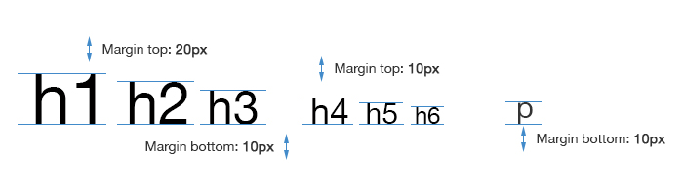

**3.3 Page Header**

Use *.page-header* appropriately space out and segment sections of content on a page with additional style.



Specifications:

|  |  |
| --- | --- |
| Font Size | 24px |
| Padding | 0 0 8px |
| Margin | 20px 0 |
| Border | Bottom - 1px Solid #CCC |

<h3 class="page-header">…</h3>

**3.4 Lead Paragraph**

Use *.lead* to make a stand out paragraph, and font size will changed if view in small devices.

Specifications:

|  |  |
| --- | --- |
| Font Size | 16px  (21px @min 768px) |
| Font Weight | 200 |
| Line Height | 1.3 |

<p class="lead">…</p>

**3.5 Text Alignment**

Align text to left, right and center are simply straight forward:

* .text-left
* .text-right
* .text-center

**3.6 Emphasis Classes**

|  |  |  |
| --- | --- | --- |
| Class | Color | |
| **HEX** | **RGB** |
| .text-muted | #999999 | 153,153,153 |
| .text-primary | #1C3F94 | 28, 63, 148 |
| .text-success | #468847 | 70, 136, 71 |
| .text-alert | #D9534F | 217, 83, 79 |
| .text-info | #3A87AD | 58, 135, 173 |
| .text-warning | #C09853 | 192, 152, 83 |

**3.7 Block Quote**

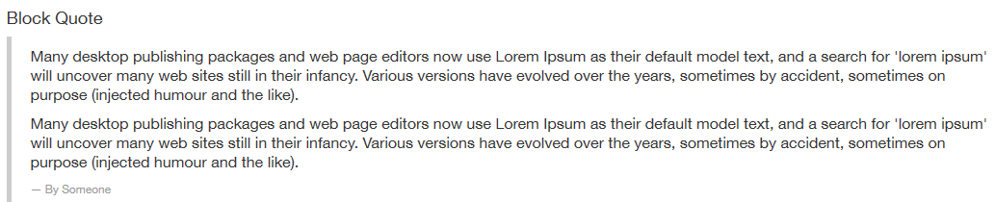Wrap *<blockquote>* around any HTML as the quote. For straight quotes, use *<p>*.

Add *<small>* tag for identifying the source. Use *.pull-right* for a floated, right-aligned blockquote.

Specifications:

|  |  |
| --- | --- |
| Padding | 10px 20px |
| Margin | 0 0 20px |
| Border Left | 5px Solid #CCC |

P

|  |  |
| --- | --- |
| Font Size | 16px |
| Font Weight | 300 |
| Line Height | 1.25 |

P: last-child

|  |  |
| --- | --- |
| Margin | 0 |

<blockquote>

<p>Quote inside the paragraph</p>

<small>Source<small>

</blockquote>

**3.8 Description**

Specifications:

dl

|  |  |
| --- | --- |
| Margin | 0 0 20px |

dt, dd

|  |  |
| --- | --- |
| Line Height | 1.4 |

dt

|  |  |
| --- | --- |
| Font Weight | 600 |

dd

|  |  |
| --- | --- |
| Margin | 0 |

.dl-horizontal dt (@min 768px)

|  |  |
| --- | --- |
| Float | Left |
| Width | 160px |
| Text Align | Right |

.dl-horizontal dd (@min 768px)

|  |  |
| --- | --- |
| Margin | 0 0 0 180px |

A list of terms with their associated descriptions.

<dl>

<dt>Term</dt>

<dd>Description</dd>

</dl>

Make terms and description in *<dl>* line-up side-by-side, use *.dl-horizontal*. Horizontal description lists will truncate terms that are too long to fit in the left column. In narrower viewports, they will change to the default stacked layout.

<dl class="dl-horizontal">

<dt>…</dt>

<dd>…</dd>

</div>

**3.9 List**

Specifications:

|  |  |
| --- | --- |
| Margin | 0 0 10px |

Nested List

|  |  |
| --- | --- |
| Margin | 0 0 5px |

.list-unstyled

|  |  |
| --- | --- |
| Padding | 0 |

.list-inline

|  |  |
| --- | --- |
| Padding | 0 |

.list-inline > li

|  |  |
| --- | --- |
| Padding | 0 10px |

<ul>

<li>

<ol>

<li>…</li>

</ol>

</li>

</ul>

Remove the default *list-style* and left margin on list items. This only applies to immediate children list items, meaning additional class for any nested lists is required.

<ul class="list-unstyled">…</ul>

Place all list items on a single line with *.list-inline*

<ul class="list-inline">…</ul>

**3.10 Code**

Specifications:

|  |  |
| --- | --- |
| Font Family | Monaco, Menlo, Consolas, "Courier New", monospace |

code

|  |  |
| --- | --- |
| Font Size | 90% |
| Color | #C7254E |
| Background | #F9F2F4 |
| Padding | 2px 4px |

pre

|  |  |
| --- | --- |
| Font Size | 13px |
| Line Height | 1.4 |
| Color | #333 |
| Background | #F5F5F5 |
| Padding | 8px |
| Margin | 0 0 10px |
| Border | 1px Solid #CCC |

Wrap inline snippets of code with *<code>*. For multiple lines of code, use *<pre>*. Be sure escape any angle brackets in the code for proper rendering.

<pre class="pre-scrollable">

<code>…</code>

</pre>

Optionally add *.pre-scrollable* to set a maximum height of 350px and provide a y-axis scrollbar.

pre code

|  |  |
| --- | --- |
| Font Size | Inherit |
| Color | Inherit |
| Background | Transparent |
| Padding | 0 |
| Border | 0 |

.pre-scrollable

|  |  |
| --- | --- |
| Max Height | 350px |

**4. Color Scheme**

|  |  |  |  |
| --- | --- | --- | --- |
| #C09853  (192,152,83) | #D6D35D  (214,211,93) | #E4E17B  (228,225,123) | #E9D71A  (233,215,26) |
| #F0AD4E  (240,173,78) | #F7F49B  (247,244,155) | #FCFA95  (253,250,149) | #FFF800  (255,248,0) |

|  |  |
| --- | --- |
| #0C2156  (12,33,86) | #1C3F94  (28,63,148) |
| #3A87AD  (58,135,173) | #428BCA  (66,139,202) |

|  |  |  |
| --- | --- | --- |
| #468847  (70,136,71) | #4CAE4C  (76,174,76) | #4DBD4D  (77,189,77) |
| #74C174  (116,193,116) | #D6E9C6  (214,233,198) | #DFF0D8  (223,240,216) |

|  |  |
| --- | --- |
| #553509  (85,53,9) | #C7254E  (199,37,78) |
| #D9534F  (217,83,79) | #F9F2F4  (249,242,244) |

|  |  |  |  |
| --- | --- | --- | --- |
| #333  (51,51,51) | #666  (102,102,102) | #999  (153,153,153) | #AAA  (170,170,170) |
| #CCC  (204,204,204) | #DDD  (221,221,221) | #EEE  (238,238,238) | #FAFAFA  (250,250,250) |

**4.1 Associated Color**

|  |  |  |  |  |  |
| --- | --- | --- | --- | --- | --- |
| #FAFAFA  (250,250,250) | #D6D35D  (214,211,93) | #E4E17B  (228,225,123) | #E9D71A  (233,215,26) |  |  |
| Default | Primary | Success | Alert | Warning | Info |

**4.2 Standard Color Template**

#FAFAFA

Some text inside the container

Submit

Cancel

#333

#CCC

**5. User Interface**

**5.1 Buttons**

Specifications:

|  |  |
| --- | --- |
| Font Size | 14px |
| Font Weight | 200 |
| Line Height | 1.4 |
| Padding | 6px 12px |
| Margin | 5px 0 0 |

.btn-lg

|  |  |
| --- | --- |
| Font Size | 18px |
| Line Height | 1.33 |
| Padding | 10px 16px |

.btn-sm

|  |  |
| --- | --- |
| Font Size | 12px |
| Line Height | 1.5 |
| Padding | 5px 10px |

.btn-xs

|  |  |
| --- | --- |
| Font Size | 12px |
| Line Height | 1.5 |
| Padding | 1px 5px |

Default (.btn-default)

Primary (.btn-primary)

Info (.btn-info)

Success (.btn-success)

Buttons can be grouping using *<div>* and give class name *.btn-group* or *.btn-group-vertical* for different arrangement.

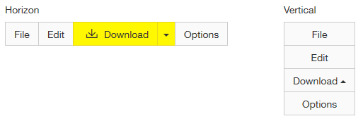

*.dropup*

Additionally, use *<div>* with class name *.btn-toolbar* to wrap multiple *.btn-group* to create more complex component.



**5.2 Input Group**

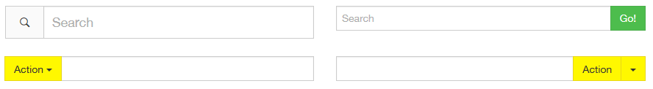Similarly, use *<div>* with class name *.input-group* with to group input fields and buttons.

Use *.pull-right* to make button float to right.

**5.3 Form Control**

Specifications:

|  |  |
| --- | --- |
| Height | 34px |
| Width | 100% |
| Font Size | 14px |
| Line Height | 1.4 |
| Color | #555 |
| Background | #FFF  (#EEE on disabled) |
| Padding | 6px |
| Border | 1px Solid #CCC  (#428BCA on focus) |
| Box Shadow | Inset 0 1px 1px  RGBa (0,0,0,0.075) |

placeholder

|  |  |
| --- | --- |
| Color | #666 |

.input-sm

|  |  |
| --- | --- |
| Height | 30px |
| Font Size | 12px |
| Line Height | 1.5 |
| Padding | 5px |

.input-lg

|  |  |
| --- | --- |
| Height | 45px |
| Font Size | 18px |
| Line Height | 1.33 |
| Padding | 10px |

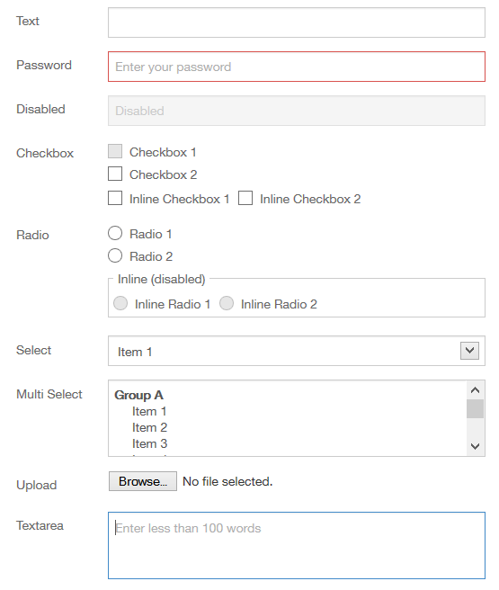

**5.4 Jumbotron**

Specifications:

|  |  |
| --- | --- |
| Font Size | 16px |
| Line Height | 1.14 |
| Color | #333 |
| Background | #EEE |
| Padding | 30px  (48px 60px @min 768px) |
| Margin | 0 0 20px |

h1

|  |  |
| --- | --- |
| Font Size | Inherit  (60px @min 768px) |
| Font Weight | 900 |
| Line Height | 1 |
| Letter Spacing | -1px |
| Color | #333 |

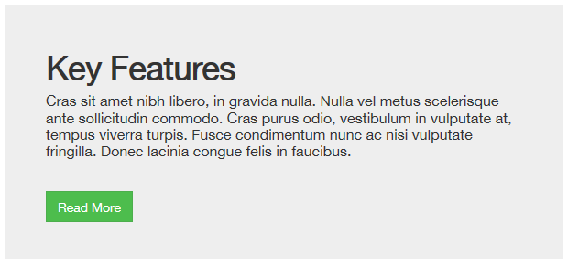

**5.5 Carousel**

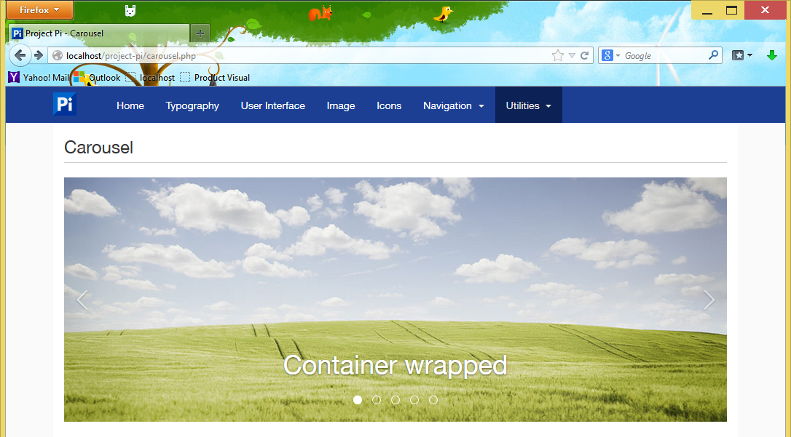Implementation of carousel is easy and without using jQuery plugin, fully customizable using CSS.

Wrap the carousel inside the container.

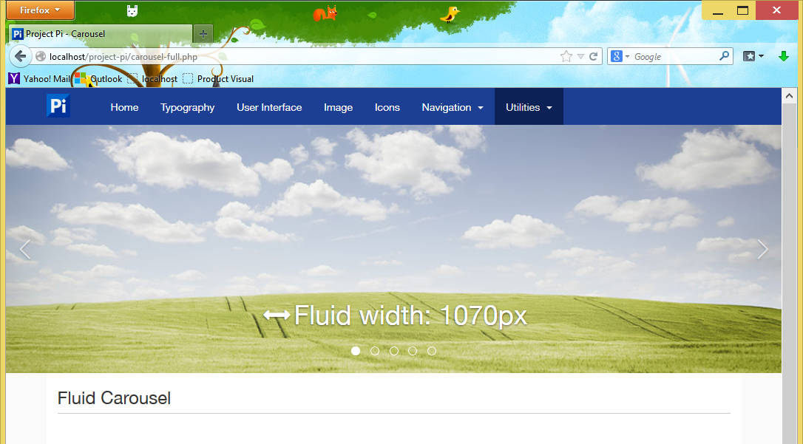

Or make it full width of the screen.

Customized CSS properties for carousel can be done depends on different design of layout.

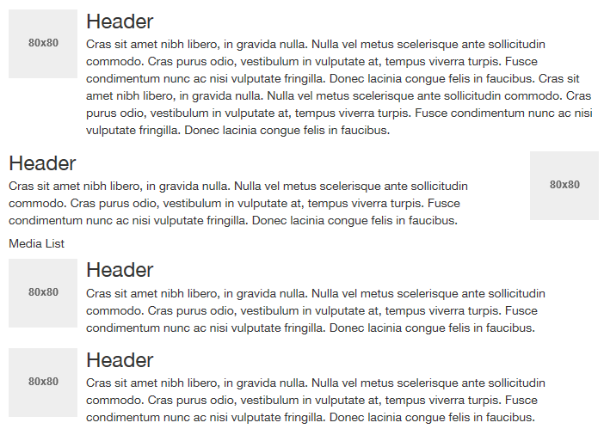**5.6 Media Object**

Specifications:

|  |  |
| --- | --- |
| Margin | 15px 0 0 0 |

.media-header

|  |  |
| --- | --- |
| Margin | 0 0 3px |

.pull-left

|  |  |
| --- | --- |
| Margin | 0 10px 0 0 |

.pull-right

|  |  |
| --- | --- |
| Margin | 0 0 0 10px |

Use *.pull-left* or *.pull-right* to change the layout.

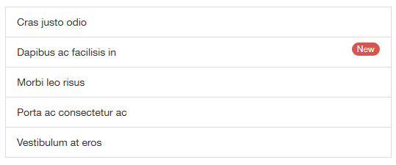**5.7 List Group**

Specifications:

|  |  |
| --- | --- |
| Margin | 0 0 20px 0 |

.list-group-item

|  |  |
| --- | --- |
| Background | #FFF |
| Padding | 10px 15px |
| Margin | 0 0 -1px 0 |
| Border | 1px Solid #DDD |

a

|  |  |
| --- | --- |
| Text Decoration | None |
| Color | #1C3F94  #333 on hover and focus |
| Background | #FAFAFA on hover and focus |

**5.8 Panels**

Specifications:

|  |  |
| --- | --- |
| Background | #FFF |
| Margin | 0 0 20px 0 |
| Border | 1px Solid Transparent |
| Box Shadow | 0 1px 1px  RGBa(0,0,0,0.05) |

.panel-header

|  |  |
| --- | --- |
| Padding | 10px 15px |
| Border | 0 0 1px 0 Solid Transparent |

.panel-title

|  |  |
| --- | --- |
| Font Size | 16px |

.panel-body

|  |  |
| --- | --- |
| Padding | 15px |

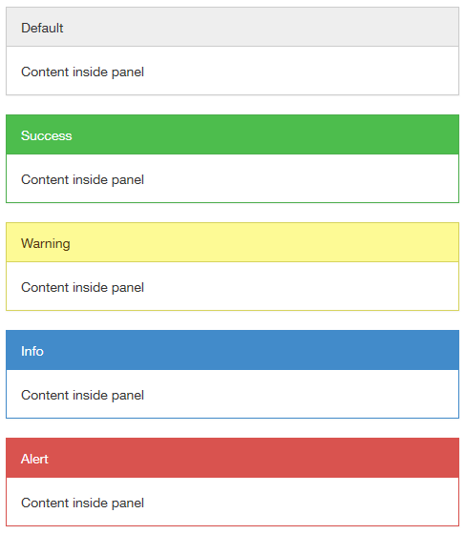

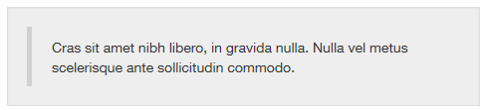**5.9 Wells**

Specifications:

|  |  |
| --- | --- |
| Background | #FFF |
| Margin | 0 0 20px 0 |
| Border | 1px Solid Transparent |
| Box Shadow | 0 1px 1px  RGBa(0,0,0,0.05) |

.panel-body

|  |  |
| --- | --- |
| Padding | 15px |

**5.10 Tables**

**5.11.6 Modal**

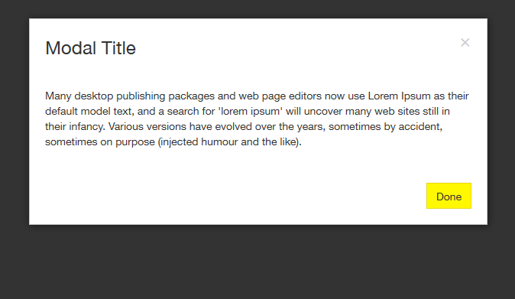Required jQuery and *bootstrap.min.js* include into the project to make it work.

Specifications:

.model-content

|  |  |
| --- | --- |
| Background | #FFF |
| Border | 1px Solid #CCC |
| Box Shadow | 1px 1px 8px  RGBa(0,0,0,0.5) |

.modal-backdrop

|  |  |
| --- | --- |
| Background | #333 |

.modal-header

|  |  |
| --- | --- |
| Padding | 20px |

.modal-title

|  |  |
| --- | --- |
| Font Size | 24px |
| Line Height | 1.4 |
| Margin | 0 |

.modal-close

|  |  |
| --- | --- |
| Margin | -5px 0 0 0 |

.modal-title

.close

.modal-body

.modal-footer

.modal-header

.modal-content

.modal-backdrop

.model-body

|  |  |
| --- | --- |
| Padding | 15px 20px 25px |

.modal-footer

|  |  |
| --- | --- |
| Padding | 10px 20px 20px |
| Text Align | Right |